H.T No
Regulations:
A17


Sreenidhi Institute of Science and Technology
(An Autonomous Institution)
Code No: 6F302 Date: 23-Dec-2019 (FN)

B.Tech II-Year I-Semester External Examination, Dec-2019/Jan-2020 (Supplementary)
Mathematical Foundations of Computer Science (CSE & IT)

Time: 3 Hours Max.Marks:75

Note: a) No additional answer sheets will be provided.
b) All sub-parts of a question must be answered at one place only, otherwise it will not be valued.
c) Missing data can be assumed suitably.

Part - A Max.Marks:25

Answer all QUESTIONS.

1. | Write about equivalence and implication formulas. | [3M]
2. | Define statement function with an example. | [3M]
3. | Verify the relation R = {(1.1) (1.4) (4,1) (4.4) (2.2) (2,3) (3,2) (3,3)} defined on  {1 ,2,3,4} is a compatibility relation or not. | [3M]
4. | Define monoid with an example. | [3M]
5. | Define tree. | [3M]
6. | Verify Euler's formula for the following graph.  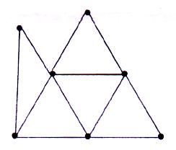 | [2M]
7. | Solve 4a_{n} - 5a_{n-1} = 0, n≥1 a₀ =1 | [2M]
8. | Write any two properties of a Lattice. | [2M]
9. | Define Isomorphism. | [2M]
10. | Define Boolean Algebra & sub Boolean Algebra. | [2M]
Part – B Max.Marks:50
ANSWER ANY FIVE QUESTIONS. EACH QUESTION CARRIES 10 MARKS.

11. | a) | Find the PDNFof 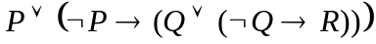 | [5M]
 | b) | Show that RS is a valid conclusion from the premise 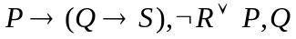 | [5M]
12. | a) | Show that | [5M]
 | b) | Solve the Recurrence Relation a_{n-1}+n, a₀ =2 | [5M]
13. | a) | If R = {(x,y) / x,y Є A,x ≥ y} is a relation defined on A = {1 ,2,3,4} then verify  that the relation R is equivalence or not. | [5M]
 | b) | Verify that (D₆, /) is a lattice or not. | [5M]
14. | a) | Write about homomorphism of semi group & monoid. | [5M]
 | b) | Verify that G = { 1,5,7,11} is a group or not under multiplication modulo 12. | [5M]
15. | a) | Write the adjacency and incidence matrices for the following graph.  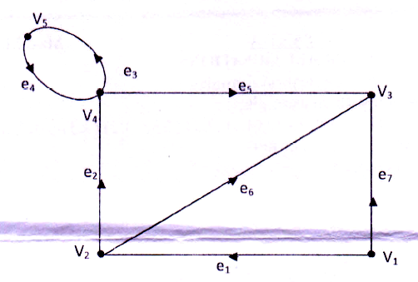 | [5M]
 | b) | Using Prim's algorithm, to find a minimal spanning tree for the following  weighted graph.  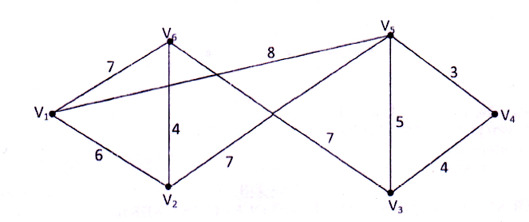 | [5M]
16. | a) | Define chromatic number and find the chromatic number of following graph.  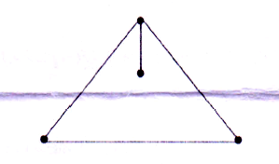 | [5M]
 | b) | Determine the number of positive integers n such that 1≤n≤100 and n is not  divisible by 2,3 or 5. | [5M]
17. | a) | Find the conjunctive normal form of 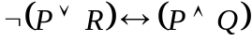 without constructing the truth table | [5M]
 | b) | Solve 2a_{n+2} -11 a_{n+1}+5a_{n} = 0,n≥0 a₀ = 2, a₁=-8. | [5M]
18. | a) | Verify that the set C of complex numbers forms a group or not with respect to  usual addition. | [5M]
 | b) | Explain about planar graph & multigraphs with examples. | [5M]

-- 00 -- 00 –

